1. **What is your cluster’s name (6 Points)?**

Answer: “Isdsbethanysmithhadoop”   
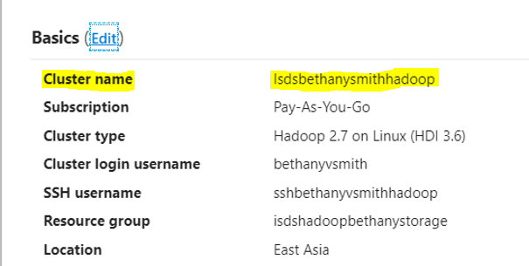

1. **When you use Putty, what should you put under Host Name to connect to your cluster (6 Points)?**

Answer: You should paste the host name into the host name in putty.

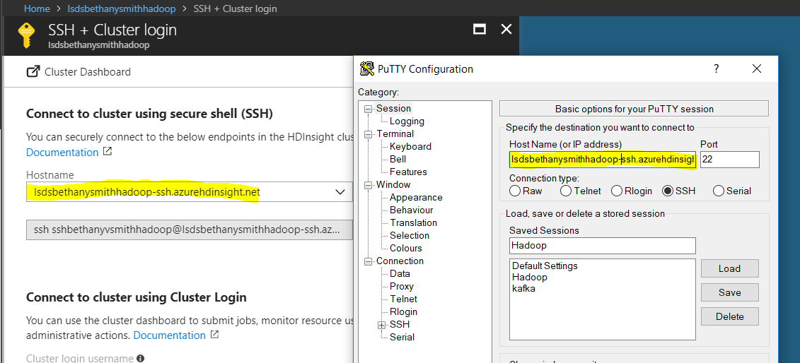

1. **What credentials do you need to use in order to log in to your host with Putty? Ssh credential or Cluster credential (6 Points)? (No need of screenshot for this question)**

Answer: After setting up your host name correctly in putty (placing the host address in the host name slot of putty) we use our Secure shell username (ssh) log in username along with our password. In order to login I entered my ssh username: sshbethanyvsmithhadoop and the accompanying password.

1. **Take a screenshot of the Ambari view to show that you have the cluster deployed and your services are on (6 Points).**

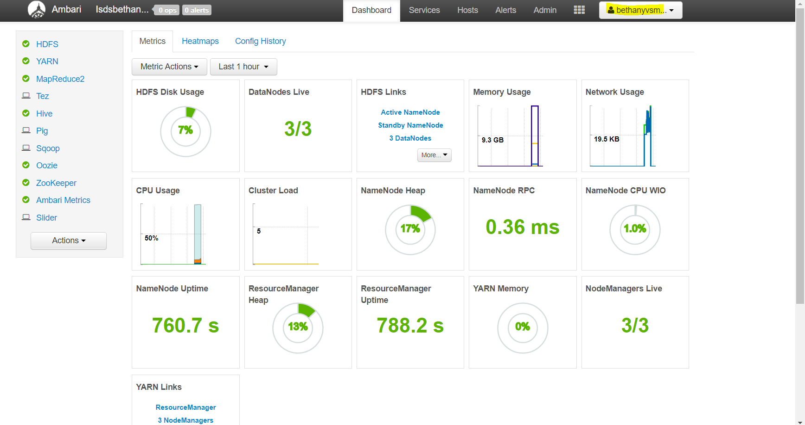

1. **Take a screenshot to show you successfully logged into your cluster (using putty, or terminal for Mac) and create a directory using:**

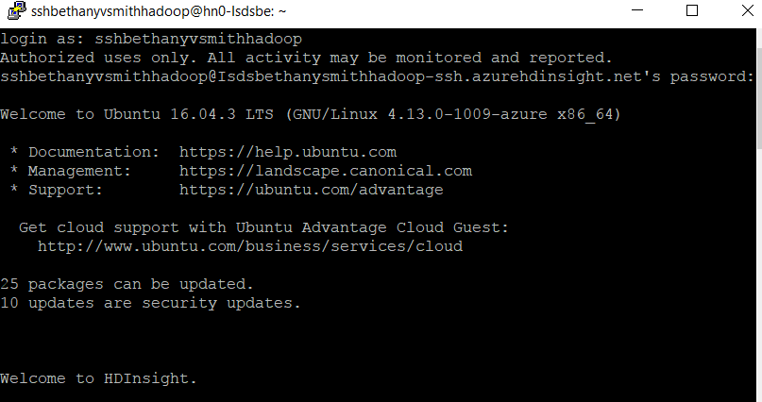

**hadoop fs –ls mkdir /yourfilepath/Hadoop_yourname**

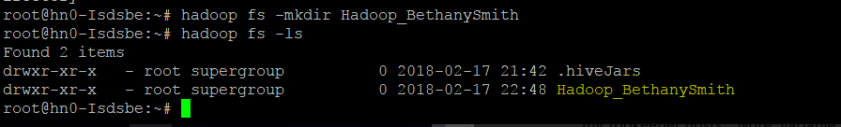

**The screenshot should show this command is executed successfully (6 Points).**